##$$Contouring of Distributions of Orientation Data

This program plots contours of densities in a Lambert projection of orientation data. Starting form and data input are the same as those of the previous programs.
In the menu 'data input' you choose the drive which contains the data or 'manual' if you want to add new data.
Manual input is also possible for universal stage data like azimuths and tilt angles of axes (i.e. quartz-c-axes) or normals to planes (i.e. poles to mica-planes). These data are converted to azimuths of dip and angles of dip internally. All further processing of these data is done in this format.
The type of data must be set in the menu 'fabric type'. In the menu ‚angle’ you choose input in the 1..360° or 1..400gon scale.
For data input from a file the fabric types "U-stage-axes" and "U-stage-poles“ are not active, because U-stage data are saved in *.LIN files.
Data input from an EXCEL-sheet is also possible. In the sheet azimuth of dip and angle of dip may either be written in a single row (with a separation key) or in two separate rows.
##$$Plot of Density Contours

The gradation of steps between the contour lines can be done either in multiples of even distribution with a logarithmic gradation or in a user defined gradation. In the first case five contour lines are calculated and automatically plotted. The steps between the contour lines are arranged in a logarithmic scale between 1 and the maximum counting density. in the first option the size of the counting calotte is fitted to the number of data, in the second option it is defined manually.
In the menu 'Colour\Contour lines' you can also choose different grades of gray for the plot of contour lines.
In the menu ‚Lines’ the line type for each contour line can be changed.
In the menu ‚Contouring methods’ further methods for the visualisation of counting densities are offered.
The menu ‚smoothing factor is used only for the Scalar product-method .
The Menu ‚Diagram’ ist the same as in the other programs.
##$$KK>>Contour Line

Contour lines are the border lines between areas of different counting densities in the projection.
##$$KK>>Counting Density

The counting density describes the number of data on a certain test area, (Counting calotte). the method was introduced by W. Schmidt (1925).

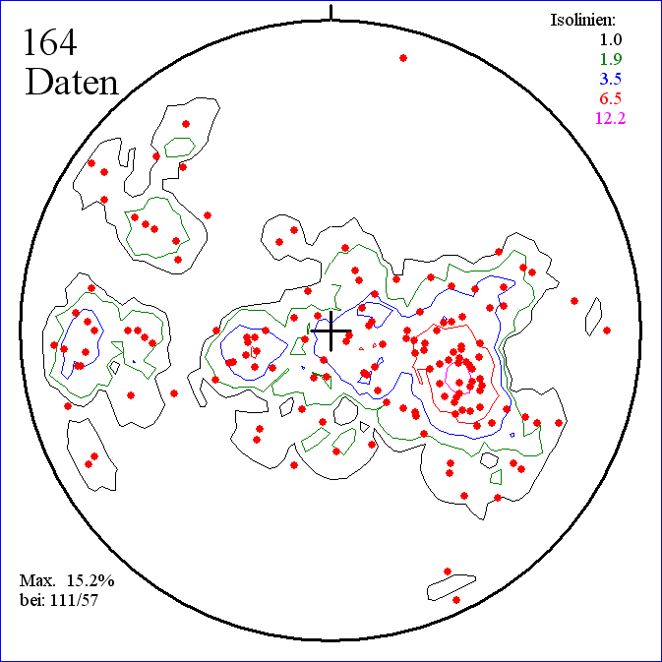

In this plot contour lines are drawn between areas of increasing counting densities.
##$$KK>>Multiples of Even Distribution

Data are evenly distributed when on the projection areas of the same size contain the same amount of data. Division of the surface of the hemisphere by the whole number of data produces the area which contains one data point in an even distribution. Multiples of even distribution are given if more then one point lies on this area.
##$$KK>>Logarithmic Gradation

The steps between the contour lines are arranged on a logarithmic scale. These steps lie between 1 and the maximum counting density.
##$$KK>>User Defined Gradation:

The gradation of the contour lines and the size of the counting calotte are set by the user.
##$$KK>>Counting Calotte:

The counting calotte is the test area which is used to find the counting density. It is a calotte of the globe.Its size is defined in percent of the hemisphere.
The size of the counting calotte is given by the apical angle of the cone which is formed by its periphery and the centre of the globe (s. Fig.).
Since the radius of the globe is 1, the surface of the hemisphere 2 π.
Thus the a-percent surface is 2 π a / 100.
The surface of the calotte is 2 π H.
Then H = a/100.
From this we receive

##$$KK>>Contouring Methods

Contour diagram can be displayed in the following ways:
1) as Vector graphics
2) as Pixel graphics in steps
3) as Pixel graphics with floating transitions
Scalar product method

1) in Steps
2) floating

##$$KK>>Mellis Method

In this method (Mellis, 1942) the counting calotte is placed on each data point of the diagram and the periphery is drawn. The amount of overlap defines the counting density.

##$$KK>>Scalar Product Method:

This method uses each pixel of the diagram as counting point. The angle between the direction of this pixel and the direction of each data point is calculated and saved as cosine functions (scalar product). See Adam, 1989). The sum of these cosines represents the counting density of the pixel.
d_{i} = counting density of the i-th pixel,
γ_{j} = angle between the pixel (as projected point) and the j-th data point
n = number of data

a data point with γ = 0 encreases d by 1. A data point with mit γ = 90 encreases d by 0.

The method produces very smooth contour lines between the counting densities. The gradation can be in steps or floating.

##$$KK>>Stepwise Gradation

In the scalar product method each counting density gets it's own colour. Change of the smoothing factor can improve the smoothness of the border lines between these colours (contour lines).

##$$KK>>Floating Gradation:

If you choose floating gradation in the scalar product method, you can select the colour spectrum from the HLS-colour circle. The complete spectrum containing all colours from 0° to 360° is plotted to the right of the diagram. The colour range which shall be applied, is chosen by clicking on the upper and the lower colour.
Change of the smoothing factor may improve the smoothness of the colour transitions.
##$$KK>>Smoothing Factor:

With an increasing smoothing factor you improve the smoothness of the contour lines. This goes together with a loss of details. You have to find the optimum by comparison with a diagram plotted with the counting calotte method. This comparison can easily be done by overlay with a counting calotte diagram. by applying the the options 'copy’ and ‚load from clipboard’ of the menu 'graphic'. This comparison with diagrams plotted with various smoothing factors lets you find the best compromise.

The smoothing factor is based on the influence of remote points. With an increasing smoothing factor the influence of a far away point becomes less important. This effect is reached by raising cosγ (s. scalar product method) to a higher power:
d_{i} = counting density of the i-th pixel,
γ_{j} = angle between the pixel (as projected point) and the j-th data point
n = number of data
g = smoothing factor
##$$KK>>Pixel graphics in Steps

The Algorithm, used here, is derived from the Mellis method. Areas of different counting densities have different colours. The gradation of steps between the contour lines can be done either in multiples of even distribution with a logarithmic gradation or they can be user defined gradation.
##$$KK>>Floating Pixel Graphics

The applied algorithm is derived from the Mellis method. The transition between the contours is done in a floating way: For each pixel of the graphic the number of calottes is counted.in which cover the pixel. Each number is represented by a colour from a stepless colour scale.
##$$KK>>Vector Graphics

The boundaries between areas of different counting densities are drawn by lines.

# HauptIso
$ HauptIso
# PlotIso
$ PlotIso
# Isolinie
$ Isolinie
K contour line
> Hilfe1
# Belegungsdichte
$ Belegungsdichte
K counting density
> Hilfe1
# Vielfache
$ Vielfache
K multiples of even distribution
> Hilfe1
# logarithmisch
$ logarithmisch
K logarithmic gradation
> Hilfe1
# benutzerdefiniert
$ benutzerdefiniert
K user defined gradation
> Hilfe1
# Kalotte
$ Kalotte
K counting calotte
> Hilfe1
# Contouring
$ Contouring
K presentation of the counting density
> Hilfe1
# Mellis
$ Mellis
K Mellis method
> Hilfe1
# Skalar
$ Skalar
K scalar product method
> Hilfe1
# Stufen
$ Stufen
K stepwise gradation
> Hilfe1
# fließend
$ fließend
K floating gradation
> Hilfe1
# Glättung
$ Glättung
K smoothing factor
> Hilfe1
# PixelSteps
$ PixelSteps
K Pixel graphics in steps
> Hilfe1
# PixelFloating
$ PixelFloating
K floating pixel graphics
> Hilfe1
# Vectorgraphic
$ Vectorgraphic
K vector graphics
> Hilfe1

